**Excel Number Formats or Datatypes:**

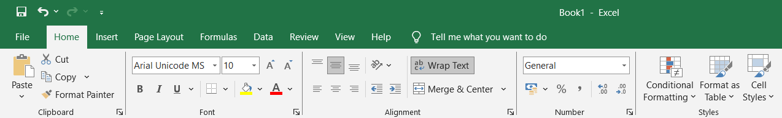Excel provides several predefined number formats to display data in a meaningful way. These formats ensure data is visually intuitive and ready for analysis. The data types available in the diagram below are explained as follows.

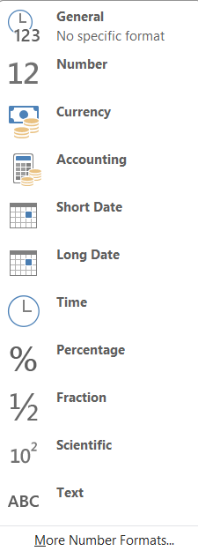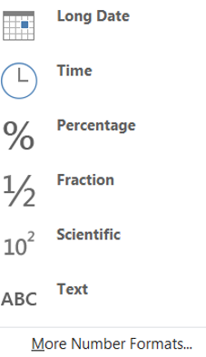

**1. General**

* **Description:** Default format for all cells. Displays numbers as entered without any specific formatting.
* **Use Case:** Best for raw data input or unformatted values.
* **Example:** Input: 12345, Display: 12345.

**2. Number**

* **Description:** Displays numbers with or without decimal points. You can customize decimal places.
* **Use Case:** Financial or statistical data where decimals are required.
* **Example:** Input: 1234.5678, Display: 1234.57 (if set to 2 decimal places).

**3. Currency**

* **Description:** Adds currency symbols ($, €, etc.) to numeric values with decimals.
* **Use Case:** Price lists or monetary calculations.
* **Example:** Input: 1234.5, Display: $1,234.50.

**4. Accounting**

* **Description:** Similar to the Currency format but aligns currency symbols to the left and numbers to the right.
* **Use Case:** Accounting and finance worksheets.
* **Example:** Input: 1234, Display: $1,234.00.

**5. Short Date**

* **Description:** Displays dates in a short format (e.g., mm/dd/yyyy).
* **Use Case:** When concise date representation is required.
* **Example:** Input: 21-Nov-2024, Display: 11/21/2024.

**6. Long Date**

* **Description:** Displays full date with the day and month name.
* **Use Case:** For formal date representation in reports.
* **Example:** Input: 21-Nov-2024, Display: Thursday, November 21, 2024.

**7. Time**

* **Description:** Displays time values (hours, minutes, seconds).
* **Use Case:** Scheduling and time tracking.
* **Example:** Input: 10:30, Display: 10:30:00 AM.

**8. Percentage**

* **Description:** Multiplies the value by 100 and adds a % sign.
* **Use Case:** Calculating rates, percentages, or proportions.
* **Example:** Input: 0.15, Display: 15%.

**9. Fraction**

* **Description:** Displays numbers as fractions instead of decimals.
* **Use Case:** Recipes or engineering measurements.
* **Example:** Input: 0.5, Display: 1/2.

**10. Scientific**

* **Description:** Converts numbers to exponential notation.
* **Use Case:** Scientific and engineering calculations involving large or small numbers.
* **Example:** Input: 123456789, Display: 1.23E+08.

**11. Text**

* **Description:** Treats the cell content as text even if it contains numbers.
* **Use Case:** For ID numbers, phone numbers, or other non-numeric data.
* **Example:** Input: 12345, Display: 12345 (as text).

**Data Validation in Excel**

Data validation ensures that users enter data correctly within a specific range or format. This feature minimizes errors and maintains data consistency.

**Steps to Apply Data Validation:**

1. **Select the Cells:** Highlight the range where validation is required.

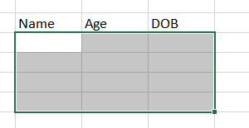

1. **Open the Data Validation Tool:**
   * Go to the **Data** tab.
   * Select **Data Validation** from the ribbon.

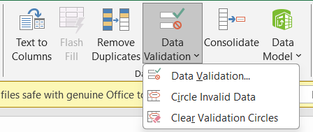

1. **Set Validation Rules:**
   * In the pop-up, define the conditions:
     + Allow: Whole Number, Decimal, List, Date, Time, Text Length, or Custom.
     + 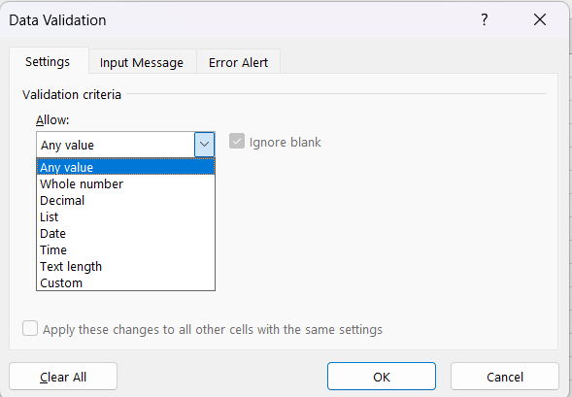Specify criteria, such as a range (e.g., between 1 and 100).
2. 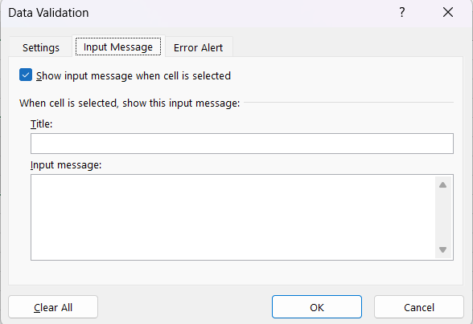**Provide Error Alerts:** Add error messages for invalid inputs to guide users.

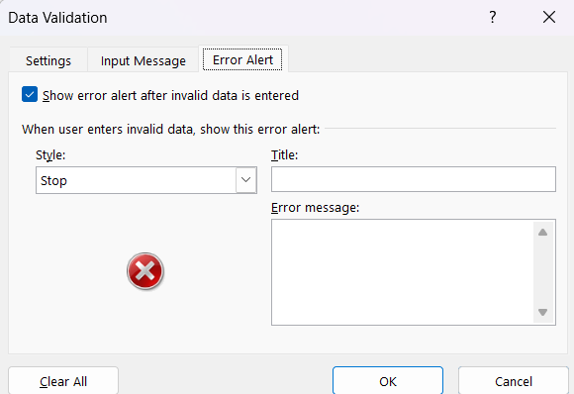

**3. Converting Data Types in Excel**

Converting data types ensures compatibility for calculations and operations. Excel offers several methods to achieve this.

**Methods for Converting Data Types:**

1. **Using Built-in Functions:**
   * **TEXT to Number:**  
     Convert numeric text to a number using VALUE.  
     Example: =VALUE("123") → 123.
   * **Number to Text:**  
     Convert numbers to text using TEXT.  
     Example: =TEXT(123, "000") → "123".
2. **Manual Conversion:**
   * For numbers stored as text:
     + Highlight the cells with a warning.
     + Click on the warning icon and choose **Convert to Number**.
3. **Using Paste Special:**
   * To convert a range to numeric values:
     + Copy a blank cell.
     + Select the range to convert.
     + Right-click → **Paste Special** → **Add**.
4. **Date and Time Conversion:**
   * Convert text to date using DATEVALUE.  
     Example: =DATEVALUE("21-Nov-2024") → Converts to a serial date number.
   * Convert time using TIMEVALUE.  
     Example: =TIMEVALUE ("10:30 AM").